

FURTHER MATHEMATICS
TRIAL EXAMINATION 1
SOLUTIONS
2006

_____________________________________________________________________

Section A Section B – answers
answers

Core Module 1 Module 2 Module 3 Module 4 Module 5 Module 6
Number Geometry Graphs Business Networks Matrices

patterns and and related and
trig relations maths decision

maths
1. B 1. B 1. D 1. B 1. C 1. D 1. A
2. D 2. D 2. D 2. E 2. D 2. B 2. C
3. C 3. B 3. C 3. A 3. C 3. B 3. B
4. D 4. C 4. A 4. E 4. B 4. C 4. C
5. E 5. A 5. B 5. D 5. D 5. C 5. C
6. E 6. E 6. B 6. B 6. C 6. A 6. B
7. D 7. C 7. D 7. C 7. A 7. C 7. E
8. A 8. C 8. C 8. E 8. D 8. D 8. D
9. E 9. D 9. C 9. D 9. A 9. D 9. D
10. D
11. B
12. A
13. C
___________________________________________________________________________

Section A: Core - solutions

Question 1

There are 23 students in the class.
The answer is B.

Question 2

The mode mark is the most popular mark; the mark that occurs most frequently. The mode mark is 17.
The answer is D.

Question 3

There are 10 people in the group (10 dots). Seven of them have less than four people living in their house.
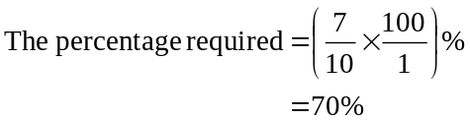
The answer is C.

Question 4
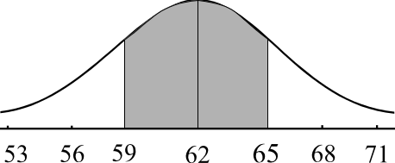
The mean height is 62cm.
One standard deviation below the mean is 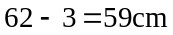.
One standard deviation above the mean is 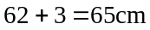.
We know that 68% of data lies between one standard
deviation below and above the mean.
The answer is D.

Question 5

A piece of data is classified as a possible outlier if it's value is less than 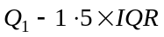 or greater than 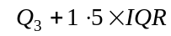. In this case 5000 is clearly not less than 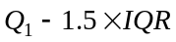.
However,
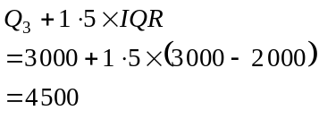
Now 5000 is greater then 4500 and therefore that is the reason that the piece of data has been classified as a possible outlier.
The answer is E.

Question 6

There are a total of 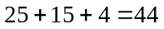 Under 16 teams. Of these, 15 train twice a week.
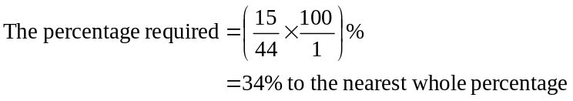
The answer is E.

Question 7

The variable height, is the independent variable since it is reasonable to expect that the length of one’s arm depends on one’s height.
The answer is D.
Question 8

The diagram below shows the three medians (indicated by a square) with a line drawn through the 2 outside medians.
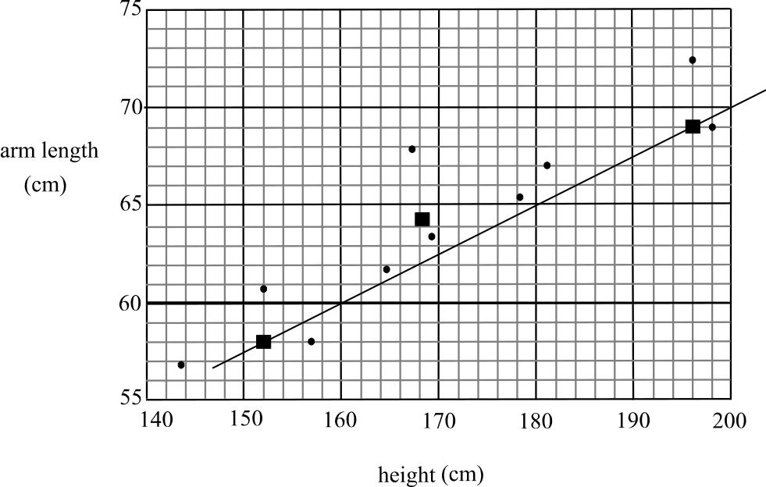

When this line is moved one third of the way towards the centre median it becomes the three median regression line.
The two outside medians are located at the points 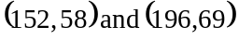.
The gradient is 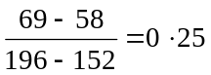.
The answer is A.

Question 9

Kate’s z-score in French is
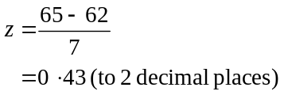
Kate’s z-score in Maths is
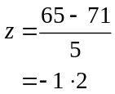
The difference in her z-scores was 1.63.
The answer is E.

Question 10

We cannot find a median for the endpoints of the time series plot so the points 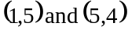 are not on the smoothed plot.
The other three medians are 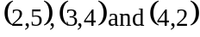.
The only one of these offered is 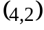.
The answer is D.

Question 11

If rentals in the first quarter are typically above the yearly average then the seasonal index for the first quarter should be greater than one.
This eliminates options C and E.
If rentals in the third quarter are typically 20% below the yearly average then the seasonal index should be 0.80.
This eliminates option A.
The four quarterly seasonal indices should add to give four.
This eliminates option D.
The answer is B.

Question 12

There is a cycle evident in the plot that has a period of 6 quarters or a year and a half.
The variation can therefore not be described as seasonal.
The answer is A.

Question 13

The first quarter represents the January-March quarter of 2001. The July-September quarter of 2008 therefore represents the 31st quarter.
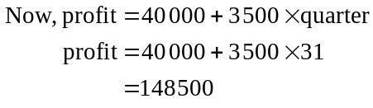
The answer is C.

Module 1: Number patterns

Question 1

The sequence is arithmetic since 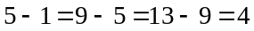.
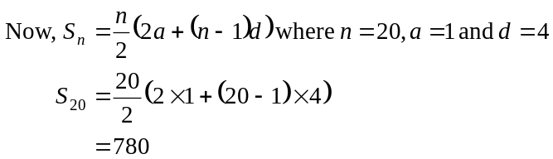
The answer is B.

Question 2

Method 1
We have an arithmetic sequence since $3 is added each week.
After nine weeks of depositing he had $73 in the account.
After another 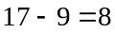 weeks he will have a further 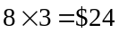 in the account. That is, he will have 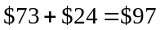 in his account.
The answer is D.

Method 2
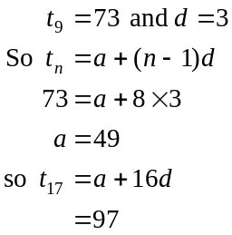

Question 3
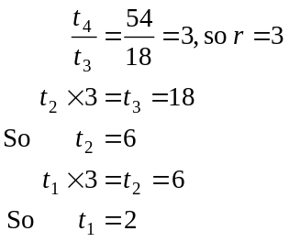
The answer is B.

Question 4
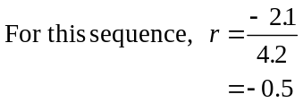
Since
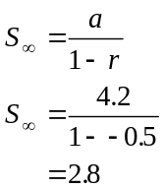
The answer is C.

Question 5

The points are in a straight line and hence the sequence must be arithmetic since each term decreases by the same amount.
Since the sequence is decreasing, 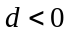. Also 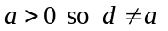.
The answer is A.

Question 6

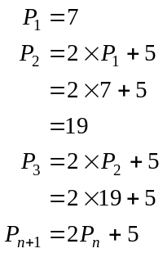
The answer is E.

Question 7

The difference equation generates an arithmetic sequence with common difference of b since b is added to each term to create the next term.
The answer is C.

Question 8

The number of feral cats increases by 2%. This represents a growth factor of 1.02.
The number of feral cats each year is given by a geometric sequence with 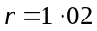.
Only option C reflects both these points.
The answer is C.

Question 9

The difference equation given is a second order difference equation.
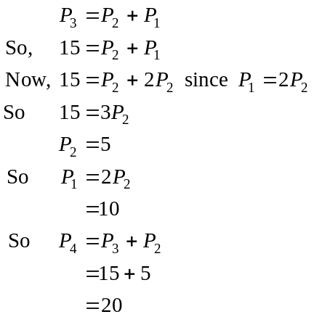
The answer is D.

Module 2: Geometry and trigonometry

Question 1

Let 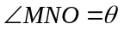
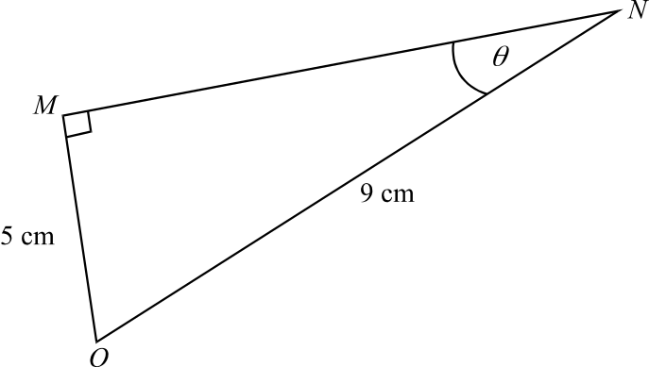

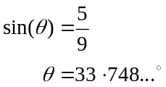
The answer is D.

Question 2

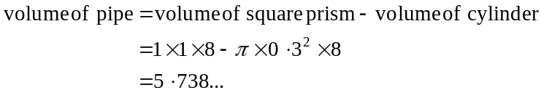
The answer is D.

Question 3

Since we are given three side lengths, use Heron’s formula.
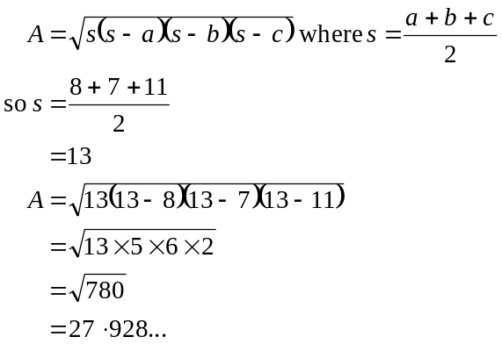
The answer is C.

Question 4

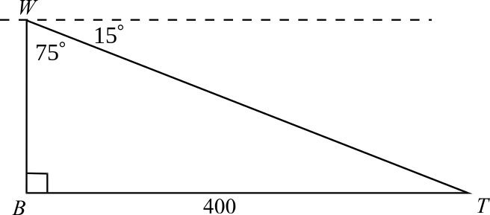

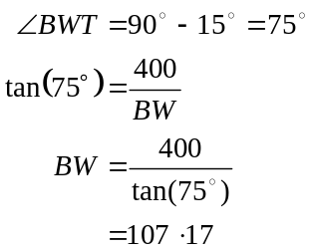
The answer is A.

Question 5
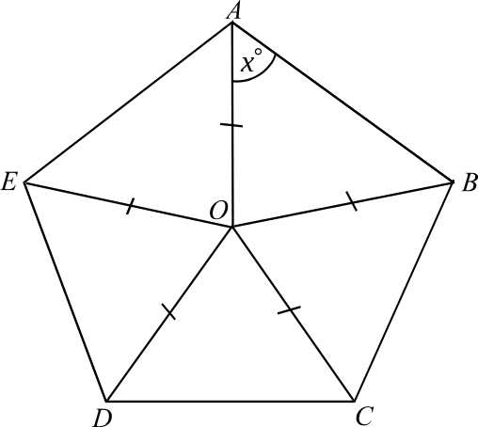

Because ABCDE is a regular pentagon,
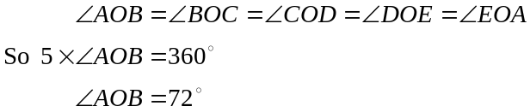
Since
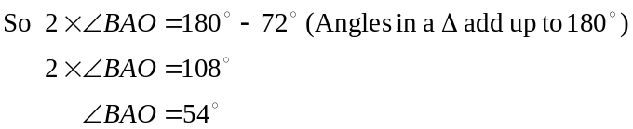
The answer is B.

Question 6

It is a non right-angled triangle so the sine or cosine rule can be used. Because there are two angles, use the sine rule.
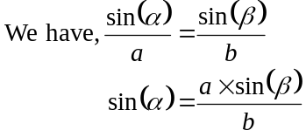
The answer is B.

Question 7
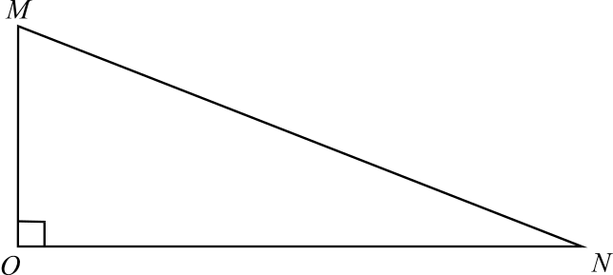

The average slope (or gradient) is 0.2.
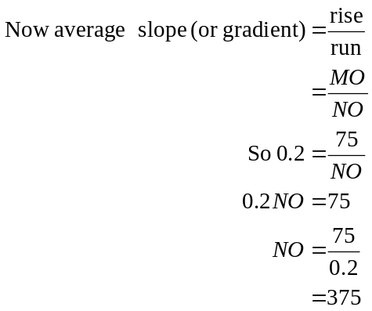
The answer is D.

Question 8

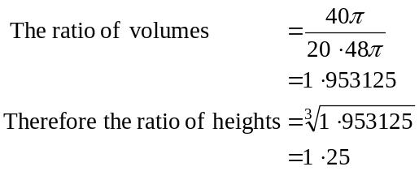
The height of the large can is 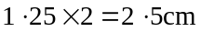
The answer is C.

Question 9
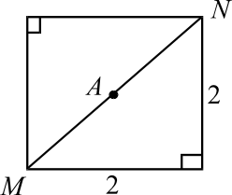
On the base of the small pyramid
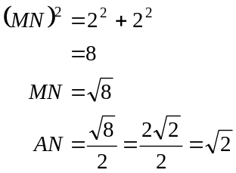
On the base of the large pyramid
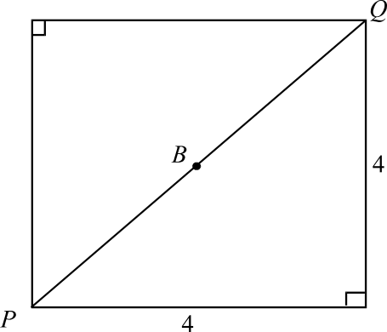
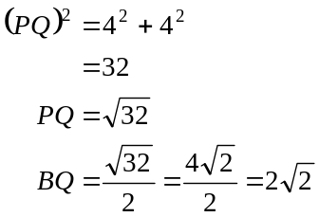
In 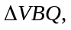
’s ANV and BQV are similar.
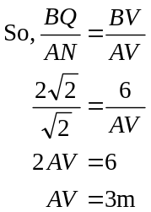
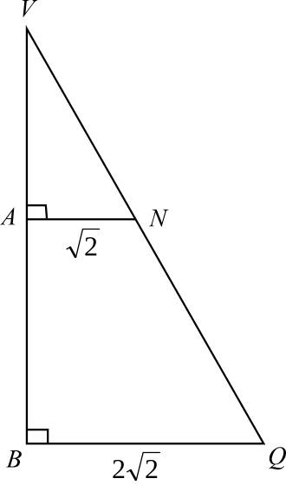
The answer is C.

Module 3: Graphs and relations

Question 1

Substitute the point 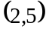 into
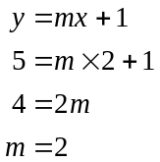
The answer is B.

Question 2

Jane’s 20 minute massage cost $20.
Kate’s 50 minute massage cost $40.
The total cost was $60.
The answer is E.

Question 3

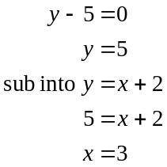
The lines intersect at 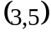
The answer is A.

Question 4

The line passes through 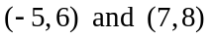.
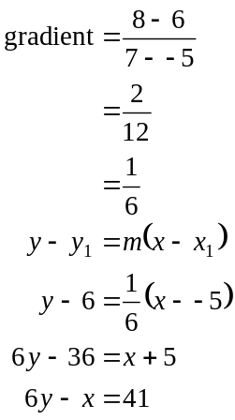
The answer is E.

Question 5

Let
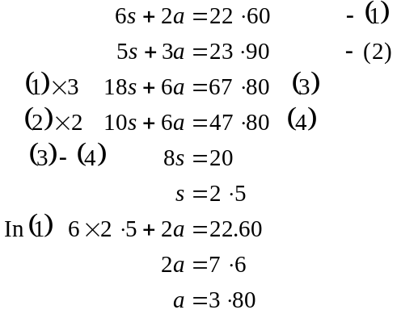
The answer is D.

Question 6

Method 1
The value of k is given by the gradient of the line; that is, 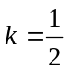.

Method 2
When 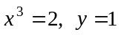.
So,
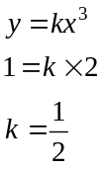
The answer is B.

Question 7

If k is negative then the y values must be negative and from the graph we see that they are not.
If k is zero then 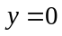.
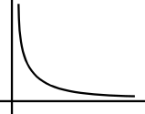

For 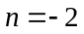 the graph is

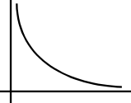
For 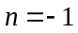 the graph is

For 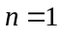 the graph is
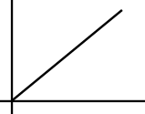

For 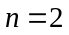 the graph is
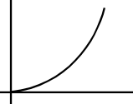

For 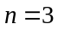 the graph is
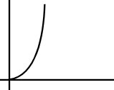

So the values of n could be – 2 or – 1.
The answer is C.

Question 8

Substitute each of the corner points into 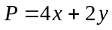.
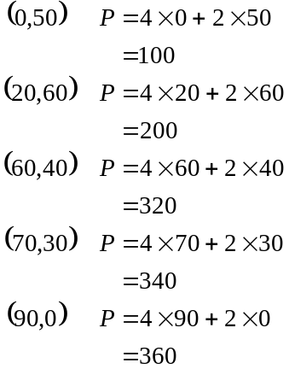
The answer is E.

Question 9

The constraints should be, .
The answer is D.
Module 4: Business-related mathematics

Question 1

The first incorrect entry made is $3 481.67 since the interest has been subtracted from
$3 482.80 instead of being added.
The answer is C.

Question 2

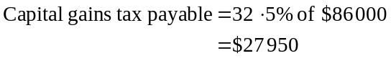
The answer is D.

Question 3

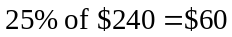
The price in the New Year sales would be $180.
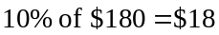
The price in February would be $162.
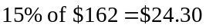
The price in March would be 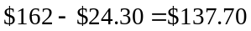.
The answer is C.

Question 4

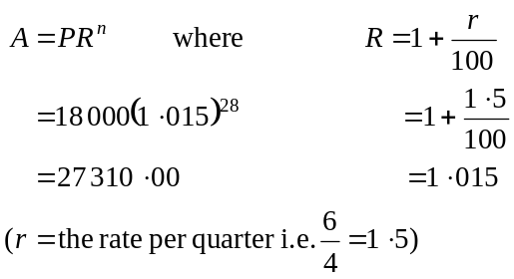
The answer is B.

Question 5

After 10 years Andrew had
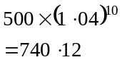
This means he had earned $240.12 in interest.
For Olivia,
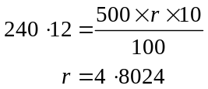
The answer is D.
Question 6
Over 4 years the motor depreciates by 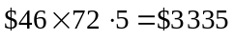. It’s original value was therefore 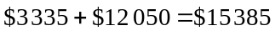.
The answer is C.

Question 7

Using TVM solver w have,
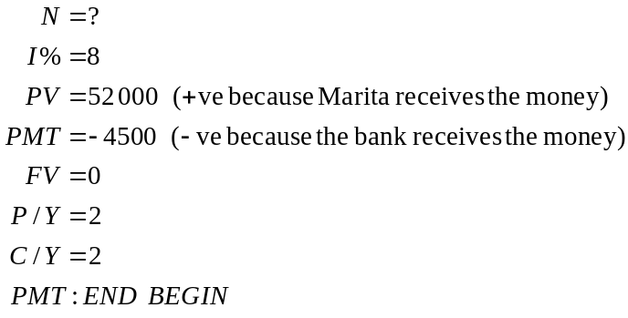
The answer is 15.815…
It takes 15.815… “half years” or 7.9075 years.
The answer is A.

Question 8

Using TVM solver w have,
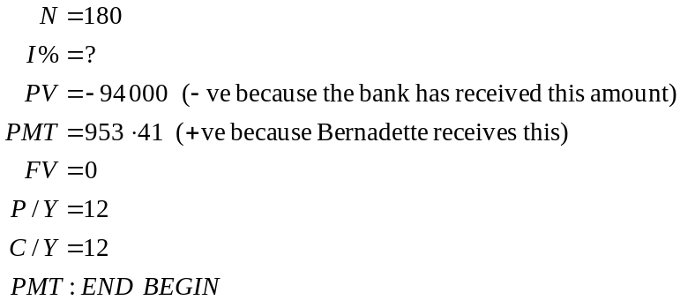
The answer is 8.999989465.
The answer is D.

Question 9
Using TVM solver w have,
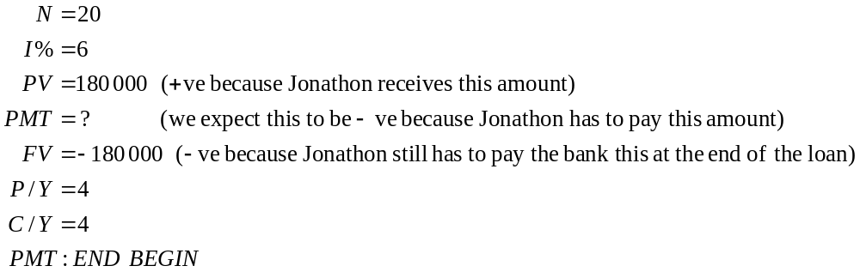
The answer is – 2700.
Jonathon’s quarterly repayment is $2 700.
The answer is A.
Module 5: Network and decision mathematics

Question 1

A complete graph has all pairs of vertices connected by an edge.
A complete graph with n vertices has 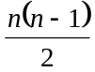 edges.
When 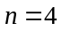, there are 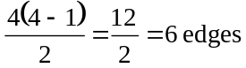.
The answer is D.

Question 2

Claire has chosen only softball so she is given that.
Paula has chosen tennis and softball.
Since Claire has been given softball, Paula is given tennis.
Andrew has chosen tennis and volleyball. Since tennis is taken, he gets volleyball and Kiran is left with soccer.
Option B reflects all this.
The answer is B.

Question 3

Euler’s formula is 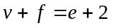
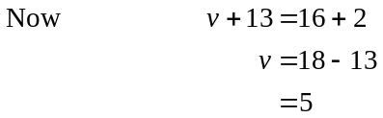
The answer is B.

Question 4

The adjacency matrix tells us that there is an edge between vertices A and D, B and C and D and E. There is a loop at vertex B.
Only graph C shows all this.
The answer is C.

Question 5

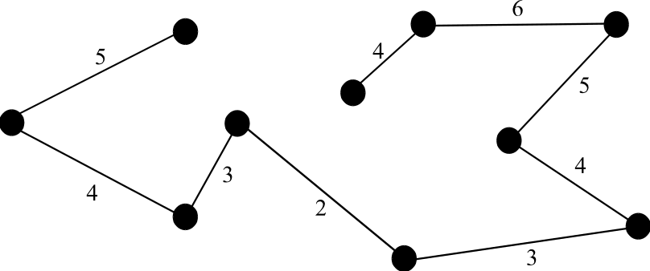

Using Prim’s algorithm, start with the edge with the minimum weight, that is, 2.
Add the next edge that is joined to the chosen edge that has the lowest weight, that is, 3.
Continue this until all the vertices are connected.
The total weight is 36.
The answer is C.

Question 6

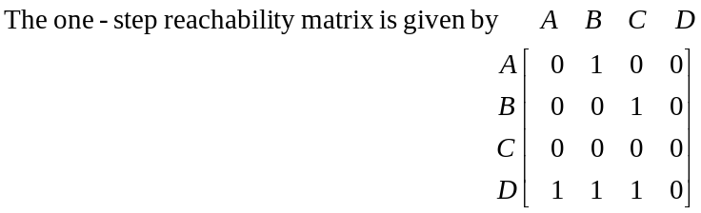
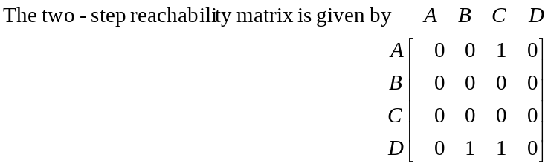
The matrix that shows both one and two-step reachability is given by the sum of these two matrices; that is,
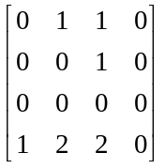
The answer is A.

Question 7

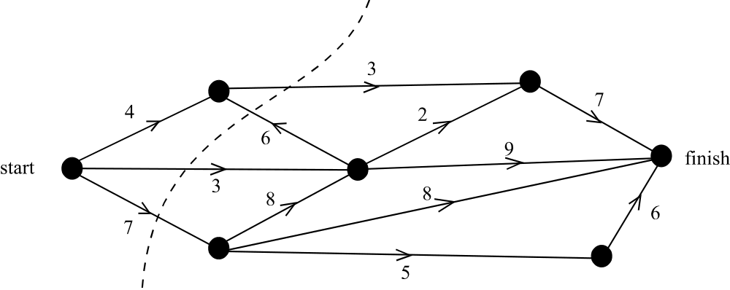

We find the cut through the network with the minimum flow. This dictates the maximum flow through the network.
Note that only the edges that run from left to right across the cut are counted. So the minimum cut is 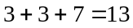.
The answer is C.

Question 8
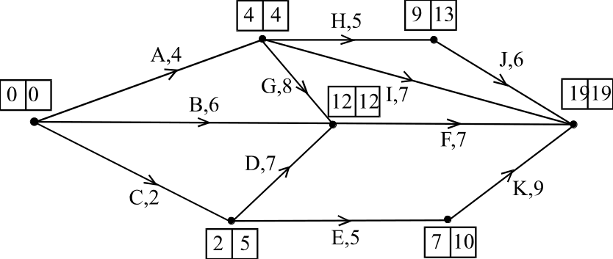

The earliest start times are shown in the left side of the box and the latest start times are shown in the right side of the box.
The critical path is A, G, F.
The length of the critical path is 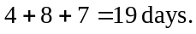
The answer is D.

Question 9

The one-step dominance is given by 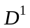.
Note, we need only work out the row for team O.
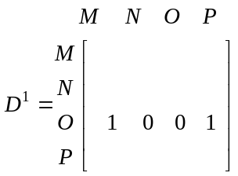
The two-step dominance is given by 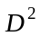.
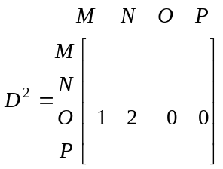

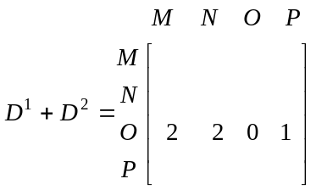
So the dominance score for one and two-step dominance is 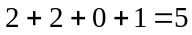
The answer is D.
Module 6: Matrices

Question 1

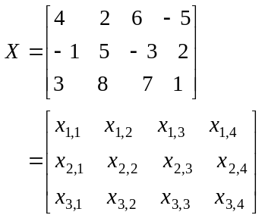
The product of element 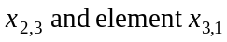
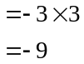
The answer is A.

Question 2

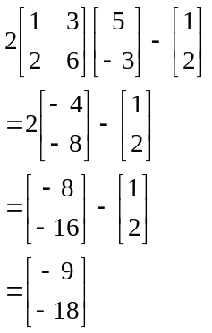
The answer is C.

Question 3

Method 1 – by hand
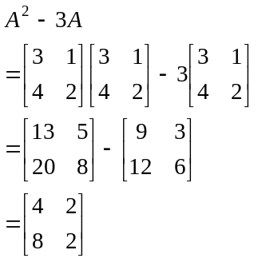

Method 2 – technology
Enter the matrix and then calculate 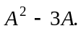
The answer is B.

Question 4

The order of matrix A is 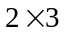.
The order of matrix B is 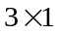.
Since the number of columns of A = the number of rows of B the product exists and the order is given by (the number of rows of A the number of columns of B) that is 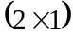.
The answer is C.

Question 5

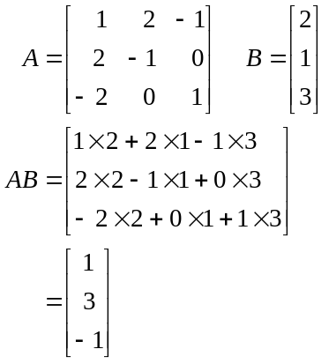
The answer is C.

Question 6

The matrix that shows the number of XRT, XRT40 and XRT80 tyres delivered to dealers during February is 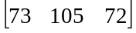.
The answer is B.

Question 7

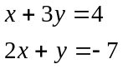
becomes
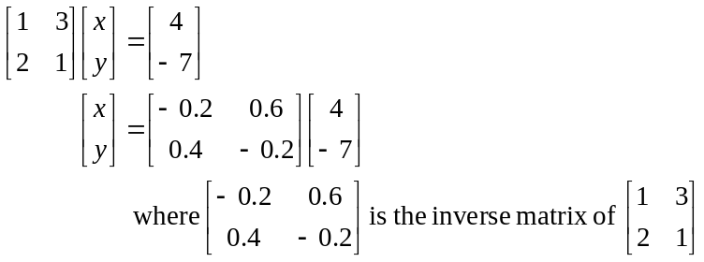
The answer is E.

Question 8

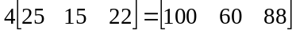
So option A gives us a 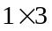 array of numbers and not a total.
The matrix product in option B gives us a matrix and not a total.
The matrix product given in option C is not defined because the number of columns of the first matrix is 3 and the number of rows of the second is 1.
The matrix product in option E gives us a 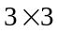 matrix and not a total.
The matrix product in option D gives us a 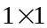 matrix, which is the total profit.
The answer is D.

Question 9

The matrix equation has a unique solution if 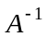 exists. Since the determinant of A equals 0, does not exist. Options A, B and C therefore are not true.
Y is not a square matrix and hence 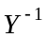 is not defined.
AX is defined because the number of columns of A equals the number of rows of X.
The answer is D.

